Schedule of Events
(SUBJECT TO CHANGE)

Friday, October 29 – Sunday, October 31:
9:00am – 5:00pm: Savannah/Hilton Head Speed Classic
Location: The Westin Savannah Harbor Golf Resort & Spa, Hutchinson Island (Savannah, GA)
Added to the HSR 2010 championship point series, the Speed Classic joins the Sebring Endurance Challenge, the Mitty at Road Atlanta, the Vintage GT Challenge at Road America and the Daytona Continental Historic Races. Those accepted as exhibitors for the Concours d’Elegance & Motoring Midway, will receive an Exhibitors Discount for these events! Come to town early, stay the week and enjoy all of the Motoring Festival’s Four Glorious Events.

Friday, November 5:
Driving Tour (Start Time TBD) – Must Register to Attend
Starting Location: TBD
Chauffer’s Society Donors Reception (Time TBD) – Must Register to Attend
Location: Discovery House, Coastal Discovery Museum at Honey Horn (Hilton Head Island, SC)

Saturday, November 6
9:00am – 4:00pm: Car Club Jamboree
Location: Coastal Discovery Museum at Honey Horn (Hilton Head Island, SC)
The Car Club Jamboree offers an eclectic mix of over 150 cars covering the history of the automobile, from modern day’s high performance muscle cars and hot rods to European sports cars. This year will feature cars from invited clubs showcasing marques that celebrate the beauty of Italian design.
Lowcountry Oyster Roast & Buffet (Time TBD) – Must Register to Attend
Location: Hilton Head Marriott Resort & Spa (Host Hotel), Palmetto Dunes Plantation (Hilton Head Island, SC)

Saturday, November 6 & Sunday, November 7:
9:00am – 4:00 pm: Motoring Midway: Memory Lane to the Fast Lane
Location: Coastal Discovery Museum at Honey Horn (Hilton Head Island, SC)
Newest to the lineup and unique to the Motoring Festival, the Motoring Midway offers a mix of days past while showcasing the vehicles of today and the technologies of tomorrow. With exhibits ranging from historic motorcycles to the newest in automotive technology, the Midway is a dynamic, interactive “trip” through the past, present and future of powered vehicles.

Sunday, November 7:
9:00am – 4:00pm: Concours d’Elegance
Location: Coastal Discovery Museum at Honey Horn (Hilton Head Island, SC)
Falling each year on the first Sunday of November, the Concours d’Elegance, the centerpiece of the Motoring Festival, showcases over 150 vintage vehicles, many of the finest in the world. Lining
the fields of Honey Horn, a historic Southern plantation, under the spreading oaks and
flowing Spanish Moss characteristic of the South Carolina Lowcountry, these historic
vehicles, compete for the coveted title of 'Best of Show.'

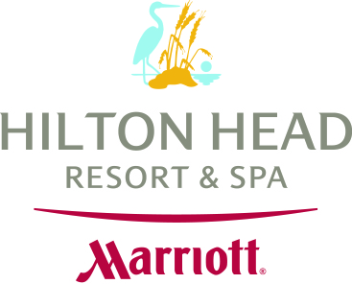

Hilton Head Marriott Resort & Spa
Official Host Hotel
of the 2010 Hilton Head Island Concours d’Elegance & Motoring Festival

(843) 686-8400
www.HiltonHeadMarriott.com
**Reservations will be accepted beginning May 1, 2010**

